Story

Chapter 1: An uneasy feeling
Each of the characters senses that something unnatural is occurring within the forest. Wishing to investigate or help, they all arrive at the bank of a fast-flowing river. The unnatural feeling is occurring on the other side of the river; however, they are presented with a challenge, how to cross the river.
Show Handout 1 and describe the environment. There are large trees growing by the river, which is flowing fast and thick with churned up mud and dirt coming from upstream. Upon looking around, there is a bundle of objects nearby. Other that Iara, none of the characters are confident about swimming here.
What do the player wish to do?
Some notes for play
1. if they investigate the bundle, they find collection of objects, Curupira knows what they are, and can draw their knowledge cards, which represent the objects that are found here (an Axe, a Helmet and a Map pointing to somewhere on the other side of the river).
2. Iara, Uirapuru and Saci Pererê can easily reach the other side.
Any play to reach the other side with all characters can be accepted, so long as it has some justification. Some examples may be: Creating a rope bridge, cutting down a tree to make a bridge or finding a path through the tree canopy which is located further upstream and requires climbing up a steep and slippery path.
After crossing the river, move onto chapter 2.

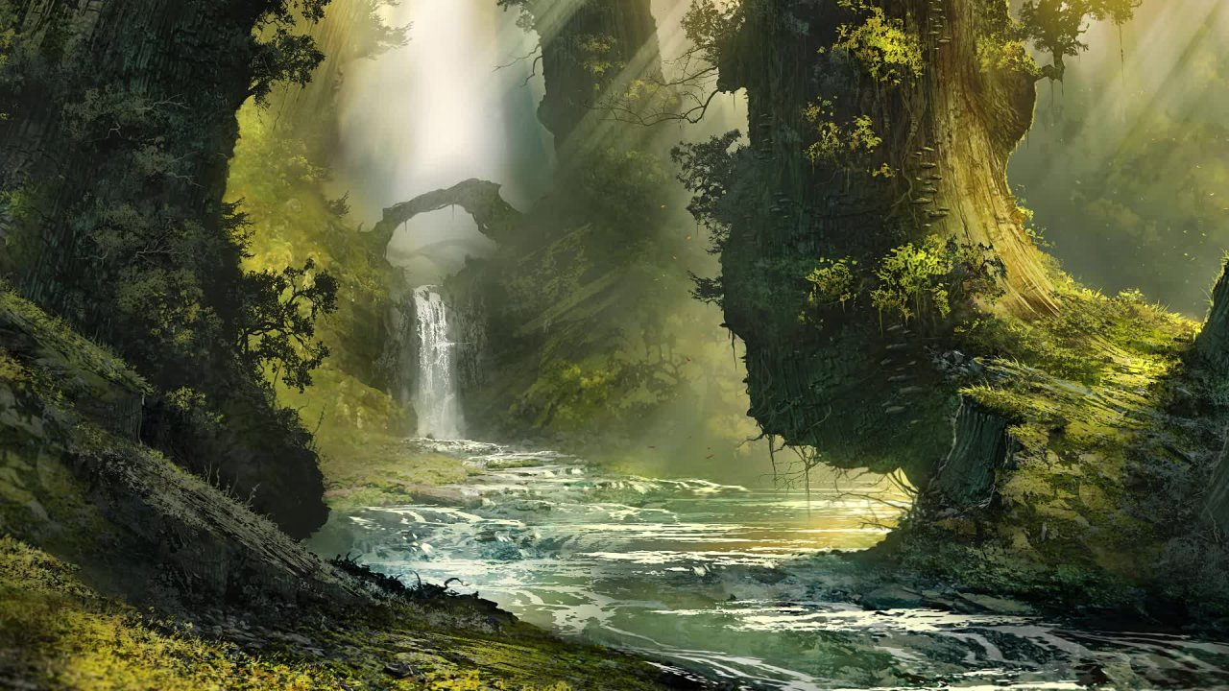
Handout 1: River Scene (Temp Art)

Chapter 2: The Blight
Upon crossing the river and reaching the source of the unnatural feelings, the characters discover a blight affecting large collection of trees and plants. A yellow fungal substance covers the plant life and is slowly killing them. (If Curupira did not investigate the earlier bundle then describe one being here as well) .
Show Handout 2 and describe the environment. Tell the players that their characters know the blight is unnatural and must be from some external intervention. Ask the players how they wish to investigate the environment?
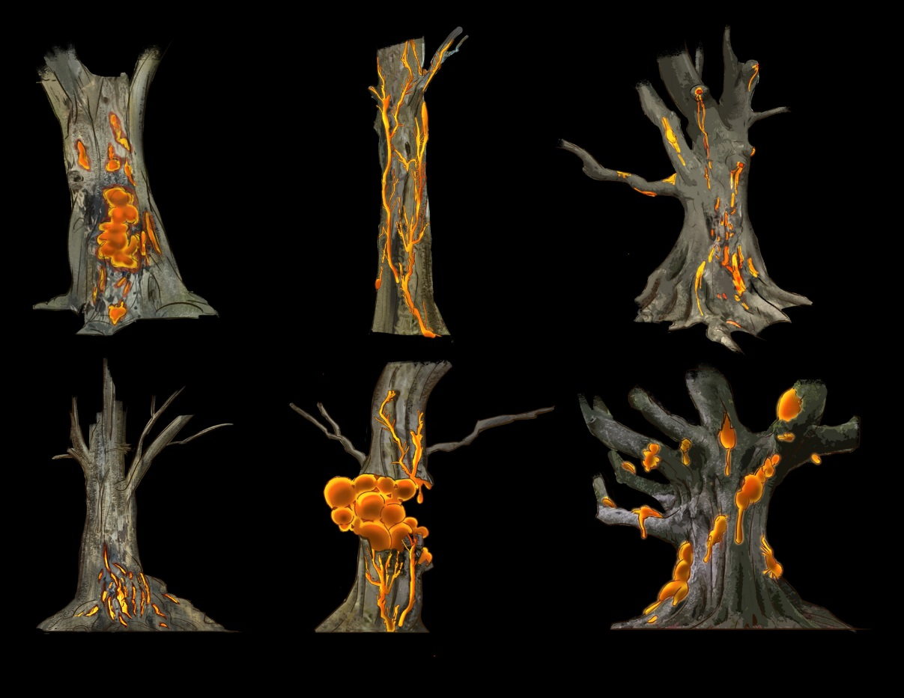
Investigation reveals:
1. Smelling the blight reveals it as sweet smelling.
2. Looking closely at the blight shows that it is shiny and wet.
3. If a player chooses to touch the blight take note of the character, and describe the blight as sticky.
4. If a player chooses to eat the blight, similarly take note, and describe the taste as foul.
5. Talking to local animal reveals all of this safely, as the local animals have had less safety precautions.
6 Burning the blight poses ineffective due to how wet and sticky it is, making it unable to catch fire.
Upon concluding the investigation, move onto chapter 3.

Chapter 3: The Plan
Anhangá, the white deer, appears to the players and starts approaching them.
Show Handout 3, and ask the Uirapuru players if they know about this character. Allow them to draw their knowledge cards and ask them to tell the group about Anhangá.
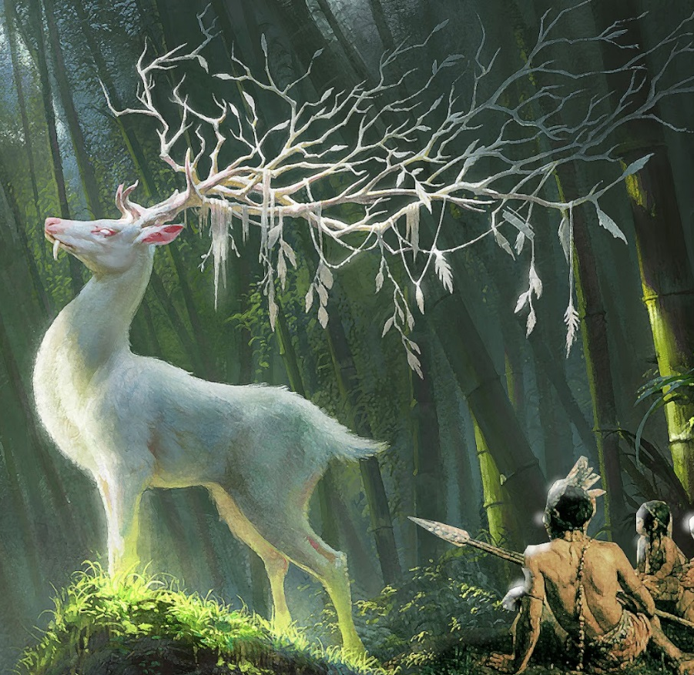
Anhangá introduces themselves and tells the players a little about the bight. (The white deer is a character useful to help guide players if they are shy with making suggestions. Use them to prompt characters into sharing information)
I am Anhangá, a defender of the forest.
He tells the players that the blight can spread, but that it could be treated through a medicine. He then tells them that Cuca, who is visiting nearby may be able to help with this.
If the Saci player does not tell Anhangá about his medicine skills, prompt them. Ask Saci to draw their knowledge cards. Anhangá will then ask Saci how they can help making this medicine, and asks Iara and Caipora what they know of local ingredients, prompting them to draw their knowledge cards.
Form here use Anhangá to help facilitate player discussion, as they form a plan to collect ingredients and produce medicine.
The players may seek out Cuca instead, in this case describe Caipora’s crocodile friends leading them to a cave and temporarily move onto chapter 4.1. (Iara may wish to use their far sight to investigate this, where you can describe Cuca being in the cave, laughing to herself) else move onto chapter 4.

Chapter 4: The Medicine
Each ingredient requires a certain character and location to collect them. Run each ingredient similar to chapter 1, where creative solutions are encouraged. The order of the first 3 steps is flexible.

Ingredient 1: Blue flower
There are 3 versions of the blue flower, with the Saci player only describing one. They each pose different challenges. Players may wish to collect them all for safety, if they are uncertain of which is correct.

Blue Lily (Iara – A flower with many petals)
Iara can lead the party to the river they crossed already, where they find a blue lily growing on the river. However, crocodiles are very visible in the water, who hiss if anyone gets too close.
Some solutions would be having Caipora ask the crocodiles to stop harassing the group and Iara gathering the flower at this point.

Blue Flower (Caipora and Curupira – A night blooming or day blooming flower)
Caipora’s map or Curupira’s friendly birds lead them back to the far side of the beginning river. The blue flowers can be seen hundreds of meters up, growing in the trees. Describe the branches this high up and thin, they cannot support much weight.
Some Solutions would be for Saci to teleport up and collect the flowers.

Ingredient 2: Water Weeds.
Iara has to choose which of the water weeds they know about to collect from the river. The correct answer is always the green one (Long and Flowing), which Saci describers.

Ingredient 3: Mushroom
Caipora leads the group to a cave, where local peccary smells a mushroom. Describe the area as rocky and the cave as very dark. Curupira may wish to light the way with their fire.
The mushroom is found not far into the cave.
Once the players collect the mushroom, describe a voice coming from further into the cave, beckoning them further into the cave. If the players wish to investigate, temporally move onto chapter 4.1.

Ingredient 4: Container
The player must find or build a container to make the medicine in.
An example solution would be using Curupira’s found helmet or Caipora digging a hole in the ground with magic.

Ingredient 5: Boiling water
Completing the medicine requires boiling water, which Curupira can produce easily with some fire.
Once the medicine has been prepared, move onto chapter 5.

Chapter 4.1: Cuca
The characters come face to face with Cuca, who looks to be making a potion. Show handout 4 and ask Uirapuru to describe Cuca.
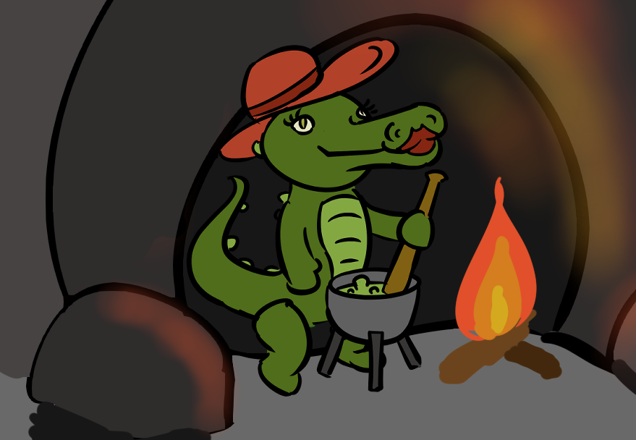
Cuca tells the player that she is preparing a vaccine for the blight, but needs one last ingredient to finish it. (if players are suspicious of the medicine, the Saci character can be told that the medicine looks safe and effective).
Cuca asks the characters to collect a Muiraquitã, that is buried on a nearby island. She is evasive as to why she cannot do it herself, as well as why she needs it.

Collecting the Muiraquitã
Collecting the Muiraquitã is a simple endeavour. The characters know where to find the island, getting to the island is a repeat of chapter 1, and digging for the Muiraquitã require either Caipora to use magic or the characters to dig manually, e.g. with a helmet.

Return to Cuca
Upon giving the Muiraquitã to Cuca, she laughs, but does hand over the medicine to the group.
Move onto chapter 5.

Chapter 5
The group returns to the blighted grove, where they can apply the medicine. Ask each character if and how they intend to apply the medicine, such as with hands or by other means. (take note again of each character who touches the blight).
Upon concluding the application, describe that the blight disappears safely and congratulate the player on completing their quest. However, for each character that touched the blight at some point describe that in a twist, the blight starts to grow on them.

Vaccination
As a final discussion, ask the blighted characters to discuss whether they would use the medicine on themselves. This is a discussion, so do not provide any direct answers, but you could make hints to in-game conspiracies, such as “maybe this was Cuca’s plan all along”.

